Diverse Leadership:
Our Future, Our Promise

25th Anniversary Commemorative Program - 2011

Division 45: The Society for the Psychological Study of Ethnic Minority Issues

2011 APA Convention Program: *25th Anniversary Celebration

Presidential Theme: Diverse Leadership—Our Promise, Our Future

Jean Lau Chin, 2010-2011 Division 45 President

Thursday 8/4/2011
10AM Symposium: Pathways to Emerging Leadership for Diverse Researchers—The New Connections Program; Presenters: Edith Arrington, Janet Chang, Enrique Neblett
Convention Center, Room 204B

3PM James Jones Conversation Hour and Invited Address—
Diversity and Leadership Style Panel: Do Contexts make a difference?
Presenters: Jean Lau Chin, Richard Suinn, Sandra Shullman
Renaissance Hotel, Mount Vernon Square Room A

4PM Links & Shoulders—Mentoring for Leadership
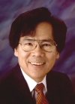
Congratulations to Links and Shoulders Program as a winner of the Richard M. Suinn Minority Achievement Award!
- Early Career Psychologists and student mentoring by division elders
- Forging alliances and promoting mentorship and leadership development opportunities within and across ethnic minority groups
Renaissance Hotel Meeting Room 12-14

6-7:50PM CEMA Social Hour
*Our Links and Shoulders Program awarded the Suinn Minority Achievement Award
Renaissance Washington Hotel, Rooms 12, 13, & 14

Friday 8/5/2011
11AM Symposium: African American Faculty and Administrator Success in Academia—Navigating Higher Education Institutions
Convention Center, Room 203
Presenters: Tina Richardson, Terrina Price, Clyde Beverly III

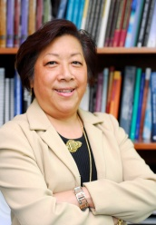
2PM Presidential Address—Diversity and Leadership
Presenter: Jean Lau Chin
Renaissance Hotel, Meeting Rm 10-11
*Awarding of Presidential Citations by Melba Vasquez

3PM Business Meeting—
*Commemorative Honoring of our Past Presidents
*Installation Ceremony

Renaissance Hotel, Meeting Rm 10-11

4-6PM Awards Ceremony and Social Hour *25th Anniversary Celebration
Fellows Initiation
Awards ceremony
*25th Anniversary Cake lighting
Social hour
Renaissance, Meeting Room 12-14

Saturday, 8/6/2011
9AM Symposium: Developing Leadership in Health Disparities through Professional Associations
Convention Center, Room 145B
Presenters: Lula Beatty, Cheryl Grills, R. Dale Walker

10AM Symposium: Opportunities and Challenges in Higher Education Administration—Experiences of three counseling psychologists of color.
Convention Center, Room 149A
Presenters: Michele Guzman, Thomas Parham, Patricia Arredondo

8PM-1AM Division 45/35 Dance—*25th Anniversary Celebration
Renaissance Ballroom South. SO YOU THINK YOU CAN DANCE? Bring your dancing shoes to this historic co-sponsor event between Division 45 and Division 35, Section 1. There’s buzz about a dance off between students and faculty/professionals. Are you willing to show off your moves during “thirty seconds of fame” down the Soul Train line? Proceeds will support a local charity.

Diversity and Leadership: We do it differently!
- 2011 President Jean Lau Chin launched her initiative on Diversity and Leadership to raise awareness, close the gap, and promote access to leadership among our talented diverse leaders!
- Join us at 25th anniversary celebratory events to learn about Division 45 and its history of leadership including special showings at Division Services, Hospitality Suite, and Social Hour:
  - DVD of past-presidents visions
  - NMCS video of Diverse Leadership Styles
  - Links and Shoulders Program -- Winner of the Suinn Minority Achievement Award
- We start all our Executive Committee meetings with a Talking Stick ceremony to include all voices and to honor our past in our present as we deliberate for the future.
- Our Council of Past Presidents continues to provide us with their wisdom on leading the division. Special honoring and new tradition to induct the past-presidents into the Council.
- With a new Strategic Plan for 2015, we seek to expand our influence and leadership toward the elimination of injustice and the promotion of diversity throughout in a new Goal 4. We ask all to consider how we can advance the infusion of culture and ethnicity into the fabric of all of our APA divisions and the profession?
- Our installation ceremony welcomes the incoming president from all our traditions.
- See our website at http://www.division45.org for resources on Ethnic Minority Psychology

Chronology of the History and Accomplishments of Division 45:

The Many Shoulders on Which We Stand:
There were no persons of color involved in the founding of the American Psychological Association in 1892, and ethnic minority issues were of the most marginal interest to the Association until the 1960’s. Indeed, when the Supreme Court in its 1954 Brown vs. Topeka Board of Education decision, ordered the dismantling of the nation’s legally racially segregated public school systems, the Association failed to acknowledge the significant impact of the psychological research and data submitted to the Court by Kenneth B. Clark and several of his SPSSI (Division 9) colleagues.

The 1960s and 1970s - Beginnings

After 1960, APA gradually effected shifts in its stance on ethnic minority issues as a result of psychological research challenging mainstream psychology’s assumptions of innate racial differences; increased racial discrimination challenges to intelligence and other psychological testing for employment and educational purposes; continual advocacy by Division 9 and by Kenneth Clark himself in his roles as APA Board member and President during the early 1970s; the increasing number, organization and advocacy of psychologists of color; and the growing social activism of the times. During the 1970s, several specific events laid the groundwork for the emergence of an APA division whose mission would be the psychological study of ethnic minorities.
- In 1974, the APA Minority Fellowship program was established and directed by Dalmas Taylor (deceased) – initiating an ethnic minority program focus at APA.
- By 1975, independent national psychological associations were established by African Americans, Asian Americans, American Indians, and Hispanics/Latino(a)s.
- In 1978, a conference on Expanding the Roles of Culturally Diverse Peoples in the Profession of Psychology (aka ‘The Dulles Conference’) was convened with the leadership of Dalmas Taylor (deceased), and funding from APA and NIMH. The conference recommended the establishment of an APA Office and Board on Ethnic Minority Affairs – both of which were established by 1980.

1980s - The Founding of Division 45
- In 1986, in response to deliberations of the APA Board of Ethnic Minority Affairs (BEMA) Task Force on Communications with Minority Constituents, chaired by John Moritsugu, the APA Council of Representatives (COR) voted to establish Division 45 (Ethnic Minorities) – thus formally integrating ethnic minority concerns into the Association. A Division 45 Steering Committee was appointed with Esteban Olmedo as President, Lillian Comas-Diaz as Treasurer, John Moritsugu as Secretary, and Melba Vasquez as the Division representative on the APA COR. Other founding members were: Hortensia Amaro, Susan Berger, Arthur Blue, Lisa Porche-Burke, Halford Fairchild, Clive Kennedy, Teresa LaFromboise, Chalsa Loo, Amado Padilla, William Parham, Charles Pine, Robert Ramos, Maxine Rawlins, Dalmas Taylor, Joseph Trimble, and Melba Vasquez.
- In 1987, Division 45 established its first Executive Committee comprised by Chalsa M. Loo and John N. Moritsugu (co-Presidents), Lillian Comas-Diaz (Secretary-Treasurer), Melba Vasquez (APA COR), Dalmas Taylor (President-Elect), Esteban Olmedo, (Past Founding President), Lisa Porche-Burke, Teresa LaFromboise, Charles Pine and Hortensia Amaro (Members at Large).
- Also in 1987, Division 45 conducted its first APA Convention Program.
- The Division’s Executive Committee established several Annual Awards.
- Dalmas Taylor (deceased) served as the Division’s third President (1988-90).

1990s - The Growing Years: Establishing Policies, Structures and Relationships
During the 1990s, the following persons served as President of Division 45: Teresa LaFromboise (1990/91) Amado Padilla (1991/93), Vera Paster, deceased (1993/94), Gordon Hall 1994/95), Charles Pine (1995/96), Guillermo Bernal (1996/97), Lisa Porche-Burke (1997/98), and Derald Sue (1998/99).

These Presidents focused on such issues as: (a) establishing the Division’s operational infrastructure including developing policies and procedures, establishing culturally-derived rituals, building membership, and establishing standing committees; (b) articulating a comprehensive and coherent vision for the Division;(c) establishing many of the Division’s signature programs and initiatives; and (d) forging alliances for ensuring the Division has ‘muscle’ within and outside the political arenas of APA.
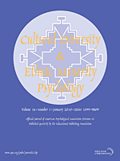
The following were a few of the significant accomplishments of the Division and its Presidents during the 1990s.
- 1990 - The establishment of the Ethnic Minority Caucus of the APA COR with Lillian Comas-Diaz as Chair, and Alice Chang as Treasurer.
- 1991 - The establishment of key task forces and committees such as the Task Force on Gay, Lesbian and Bisexual Concerns (chaired by Eduardo Morales), which orchestrated the Division’s stance against the armed Forces’ policies on gays and lesbians, and forged an alliance with Division 44 (Society for the Psychological Study of Lesbian, Gay, Bisexual and Transgendered Issues).
- 1994 - The Division’s award-winning Links and Shoulders initiative, a graduate student mentoring program, was established under the leadership of Vera Paster (deceased) and subsequently is conducted at every APA convention.
- 1995 - With the leadership of Gordon Nagayama Hall, the Division entered ‘major league’ APA politics through its organized efforts in support of the candidacy of Richard M. Suinn for APA President.
- 1998 - As a result of the efforts of Guillermo Bernal, Lisa Porche-Burke, and others, the Division launched its journal, Cultural Diversity and Ethnic Minority Psychology with Lillian Comas-Diaz as Editor, thus ensuring both the visibility of ethnic minority psychological research, and a significant stream of income to the Division.
- 1999 - APA elected Richard M. Suinn as APA President.
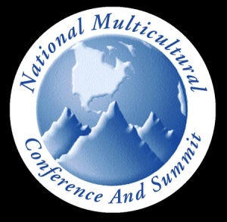
- 1999 - As a result of cooperation among a landmark number of persons of color serving as APA Division Presidents, the Inaugural National Multicultural Conference and Summit was convened in Newport Beach, CA under the leadership of the Division (Derald Sue, Conference Chair) and with co-sponsorship of Divisions 17 (Counseling), 35 (Women) and 44 ( GLBT). Subsequently, the NMCS has been convened biennially with the co-sponsorship of Division 45.

2000 to 2011 - Coming into Its Own
The following persons served as President of Division 45 during the 2000-2011 period: Joseph Trimble (1999/2000), Patricia Arredondo (2000/01), A. J. Franklin (2001/02) Jeffrey Mio (2002/03), Steven James (2003/04), Eduardo Morales (2004/05), A. Toy Caldwell-Colbert (2005/06), Frederick Leong (2006/07), Elizabeth (Beth) Boyd (2007/08), J. Manuel Casas (2008/09), Robert Sellers 2009/10), and Jean Lau Chin (2010/11).

Due to both continuous membership growth (out of 54 APA Divisions, Division 45 is one of about half a dozen that exhibit membership growth) and the significant and continuously increasing revenue generated by its journal and other publications, the Division entered the 21st Century in a fairly comfortable financial condition. In addition, prior (and continuing) infrastructure-building efforts resulted in increased efficiency of Division operations and structures. Consequently, this opening decade of the 21st century, became one in which the Division stretches its legs a bit -- taking more risks, engaging more actively in strategic innovation, and more assertively advocating for ethnic minority concerns both within and outside of APA.
- 2000 - The Division’s Executive Committee established a Graduate Student Representative (Lawrence Yang) position and authorized a Student Committee.
- The Division 45 website was launched.
- 2001 - As Division President, Anderson J. Franklin was one of 6 APA delegates to the UN World Conference against Racism, Racial Discrimination, Xenophobia, and Related Intolerance in Durban, South Africa – thus initiating the Division’s involvement in global public policy issues.
- 2002 - The Division’s membership growth and support resulted in its acquiring a second APA COR.
- 2003 - Publication of Handbook of Racial and Ethnic Minority Psychology (edited by Guillermo Bernal, Joseph Trimble, Ann Kathleen Burlew, & Frederick T. Leong) with proceeds to Division 45.
- 2006 - The Division established a continuing Task Force on Scientific Affairs, chaired by Norweeta Millburn, which, with the support of division President Fred Leong, advocated for increased attention to ethnic minority perspectives in deliberations of the APA Board of Scientific Affairs and in APA’s scientific journals.
- 2006 - As part of her presidential initiative, A. Toy Caldwell-Colbert (deceased) partnered with Division 35 (Women) and the APA President (Gerry Koocher) in organizing the first national psychological conference on immigration.
- 2007 - Division 45 Council Representative William Parham acted as floor manager for COR’s consideration of proposed resolution calling for authorization of a membership bylaws change vote to allow the establishment of 4 COR seats for representatives of the national ethnic minority psychological associations. COR approved the vote, but the membership vote was opposed to the bylaws change.
- 2007 - The Division co-sponsored a conference on Culturally Informed Evidence-Based Practice chaired by Eduardo Morales.
- 2007 - As part of its continuous commitment to students, Division 45 established Psi Alpha Omega – “the national honor society in psychology for students of color and students interested in the study of ethnic and cultural issues” (Joseph Horvat, Founding Executive Director).
- 2007 - The Division’s Book Series was launched under the leadership of Frederick T. Leong.
- 2008 - The Division’s Council of Past-Presidents was established under the leadership of Beth Boyd.
- 2009 – J. Manuel Casas drafted a manuscript urging greater APA involvement in issues related to psychological aspects of immigration. Subsequently, APA President Melba Vasquez established a Task Force on this issue.
- 2010 - As part of his presidential initiative, Robert Sellers organized and chaired the first 2010 Division 45 Conference emphasizing the presentation of scientific research on ethnic minority issues.
- 2011 – As her presidential initiative, Jean Lau Chin promoted the need for and benefits of Diversity and Leadership.

For more information about the history of Division 45, visit our hospitality suite and website http://www.apa.org/about/division/div45.aspx.

Photo Gallery – Can you identify the past-presidents of Division 45?
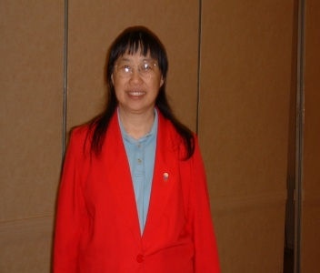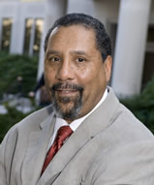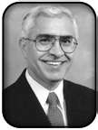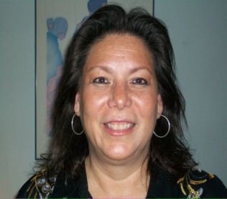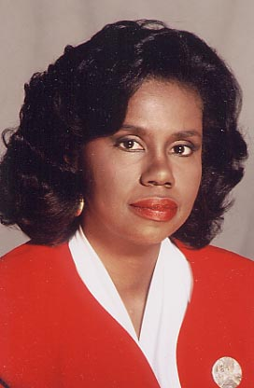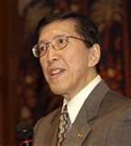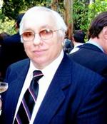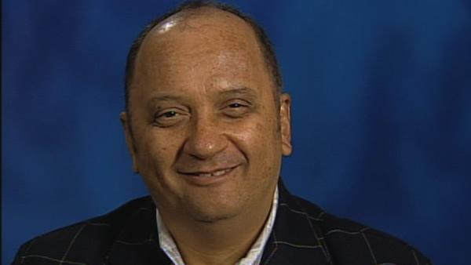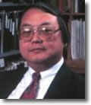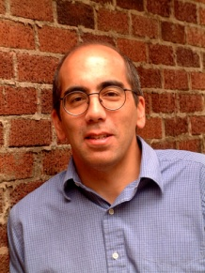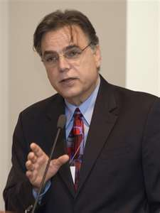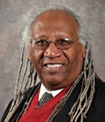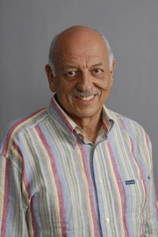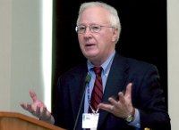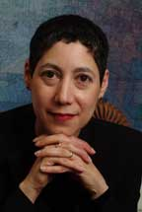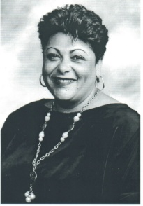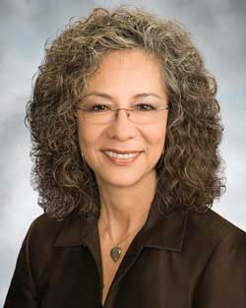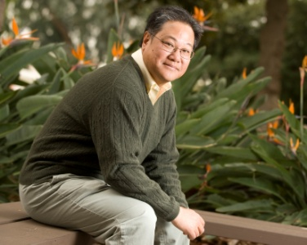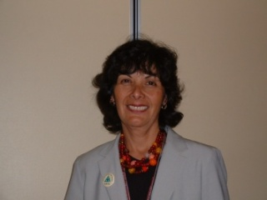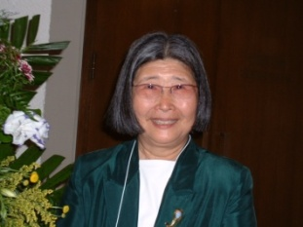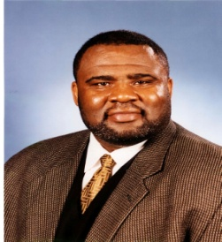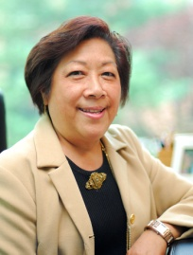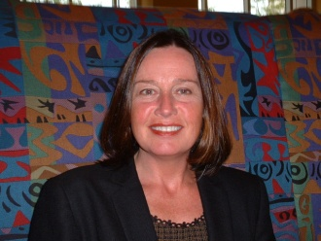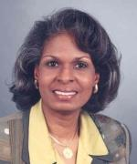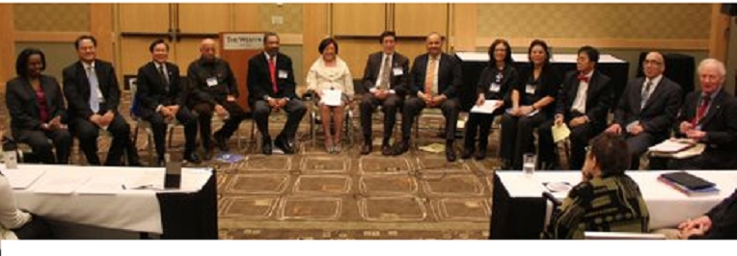

2011 Division 45 Leadership
Officers
Jean Lau Chin, EdD, ABPP, President
Justin (Doug) McDonald, PhD, President-Elect
Robert M. Sellers, PhD, Past-President
Priscilla Dass-Brailsford, EdD, Secretary
John Gonzalez, PhD, Treasurer
Jeffrey M. Ring, PhD, Member-at-Large – Diversity Slate
Lisa Rey Thomas, PhD, Member-at-Large, Native American Slate
Melanie Domenech Rodríguez, PhD, Member-at-Large Latina Slate
Jennifer J. Manly, PhD, Member-at-Large African-American- Slate
Michi Fu, PhD, Member-at-Large Asian American Slate
Jessica Henderson Daniel, PhD, ABPP, APA Council Representative (2009-2011)
William D. Parham, PhD., ABPP, APA Council Representative
Andrea Ballesteros, MA, Student Representative

2010-2011 Standing and Ad Hoc Committee Chairs
Michael A. Zårate, PhD, CDEMP Editor
Melissa L. Morgan, PhD, FOCUS Newsletter Editor
Shamin Ladhani, Psy.D, Membership Chair
Jae Yeon Jeong, Ph.D., Web Coordinator
Debra Kawahara, PhD, NMCS 2013 Coordinator
Jennifer. I. F Durham, PhD, APA Programming co-chair
Veronica Orozco, PhD, APA Programming chair
Azara Santiago-Rivera, PhD, Fellows Chair
Asuncion Miteria Austria, PhD, Finance Committee, Chair
Azenett Garza-Caballero, Ph.D., Director, Psi Alpha Omega
Beth Boyd, PhD, Council of Past President’s Chair
Bertha G. Holliday, PhD, Co-Historian
Felicisima C. Serafica, PhD, Co-Historian

Leadership within Division 45: Presidential Initiatives
Esteban Olmedo (1986): Defined and developed organizational characteristics, structure and functions of the new division.
Chalsa Loo and John Moritsugu (1987-88): Established divisional infrastructure and regularities.
Dalmas Taylor (1988-90): Initiated membership drive to increase division membership.
Teresa LaFromboise (1990-91): Appointed a Task Force on Gay, Lesbian & Bisexual Concerns and a Task Force on Women.
Amado Padilla (1991-93): Established a Publications Committee to plan for an official division journal.
Vera Paster (1993-94): Founded “Links & Shoulders,” a mentorship program.
Gordon Hall (1994-95): Developed a strategic plan to increase membership, add an APA COR seat, elect an ethnic minority president of APA, and establish an official division journal.
Charles Pine (1995-96): Instituted culturally-based Division 45 traditions and rituals.
Guillermo Bernal (1996-97): Oversaw launching of official division journal, Cultural Diversity and Ethnic Minority Psychology.
Lisa Porche-Burke (1997-98): Sponsored scholarly discussion on Ebonics.
Derald Sue (1998-99): Initiatives on multicultural competencies and dissemination of ethnic minority scholarship, Inaugural National Multicultural Conference & Summit.
Joseph Trimble (1999-2000): Introduced Talking Stick ceremony, student involvement in division governance, division recognition of outstanding student poster presentations, Division 45 web site, initiated a royalty procedure where book authors and editors contribute a percent of their royalties to the division.
Patricia Arredondo (2000-2001): Collaborated with several APA divisions on multicultural and diversity initiatives, introduced spiritual Mestizo ceremony during division business meetings.
A.J. Franklin (2001-2002): Attended United Nations World Conference and advocated on behalf of Division 45 against racism in Durham, South Africa at the United Nations World Conference.
Jeffrey Mio (2002-03): Built bridges with allies, using a broader definition of diversity.
Steven James (2003-04): Brought attention to people of mixed races and their families, and to historical abuse of people of color.
Eduardo Morales (2004-05): Developed proposal for a conference on evidence-based interventions and developed five-year (2005-10) strategic plan for Division 45.
A. Toy Caldwell-Colbert (2005-06): Organized a national conference on immigration, in collaboration with Division 35. Celebration of Division 45's 20th anniversary.
Fred Leong (2006-07): Launched Division 45 Book Series, Established Task Force for Scientific Affairs, Presidential Citations for leading psychological scientists from Division 45.
Beth Boyd (2007-08): Established Council of Past Presidents.
J. Manuel Casas (2008-09): Advocated for greater attention to immigration and children.
Robert Sellers (2009-2010): Initiated Inaugural Division 45 Conference.
Jean Lau Chin (2010-2011): Diversity and Leadership Initiative to promote division 45 leadership. Celebration of Division 45’s 25th Anniversary and logo pin for induction of past-presidents.

A New Strategic Plan 2015 for Division 45
Mission
The Society for the Study of Ethnic Minorities is for psychologists concerned with ethnic minority issues. We promote understanding of ethnic minority psychological principles, and provision of culturally competent service delivery. We promote the elimination of racism and social injustice against People of Color and the incorporation of diversity and multiculturalism into all societal issues. The Division encourages empowerment inclusion and collaboration among psychologists, promotes multicultural research, education and training regarding People of Color, and represents these concerns within the American Psychological Association and to the public.

Vision: What does Division 45 mean to you?
- The go to source for relevant and leading edge psychological science concerning diverse populations
- Strives to end racial and ethnic inequalities of power and privilege that affect psychosocial well being
- A beacon for racial/ethnic minority issues in psychology that impact diverse lives
- The voice for cultural diversity and ethnic minority psychology within APA and society
Strategic Goal 1: That the division becomes a diversity psychology home where members find support, encouragement and tangible resources to enhance their work and wellbeing in diversity psychology
Strategic Goal 2: That the division serves as a moral compass with regard to diversity to promote an active, engaged relationship with APA relevant to Division 45 strategic goals
Strategic Goal 3: That the Division 45 Board will be an effectively functioning body, closely engaged with and relevant to the needs of membership with outcomes consistent with the Strategic Plan
Strategic Goal 4: Promote the elimination of racism and social injustice in society through research, education, practice, policy and advocacy
Go to: http://www.division45.org/strategic_plan for the entire strategic plan.

The Gift of Membership

Help Us Shape Psychology’s Future! Join the Dynamic Society for the Psychological Study of Ethnic Minority Issues, Division 45! It is the go to place for incorporating diversity and multiculturalism into all societal issues. Moreover, its members are made up of the best of the best in multicultural psychology and are committed to supporting the field and your success in psychology. Sign up and get acquainted with us! To join, go to http://www.division45.org/membership.

Commemorative 25th Anniversary Logo Pin will be given to all Division 45 members at the Convention.
Join now and enter a lottery for free memberships!

